Office Use Only
Student Status:
□ Current
□ Returning
□ New

□ Registration Form
□ Registration Fee

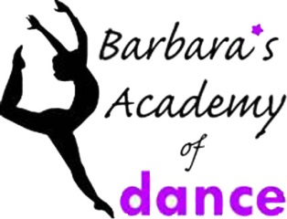

40th Anniversary Registration Form

Student Information

Full Name:___________________________________________________________ Date of Birth _____-______-_____

Address:__________________________________________________ Apt:_________________

City:____________________________ State:______________ Zip Code:______________________________________

Home Phone: (_____)_____________________________ Cell Phone: (______)_________________________________

Health Issues:_____________________________________________________________________________________

Student E-Mail:_____________________________________________________________________________________

How you hear about us:________________________________________________This is my___________________year

Parent(s)/Guardian(s)

Mother/Guardian:_____________________________________ Father/Guardian:________________________________

Home Phone: (_____)_________________________________ Work Phone (_____)______________________________

Cell Phone: (_____)__________________________________ E-Mail:__________________________________________
Register Me for the Following Classes:

Class | Day | Time
Authorization:
I have read and agree to Barbara’s Academy of Dance policies and procedures.

Parent or Guardian Signature X________________________________________________

Please mail this registration form & fees to: 82 4th Avenue, Lowell, MA 01854

